A Summary Of Matassa Olla Rouge

For those with a penchant for hands on experiences, consider gifting a natural wine making kit. As the world of wine continues to evolve, more enthusiasts are delving into the art of crafting their own blends. Whether for personal enjoyment or as a unique gift, natural wine making kits offer a fascinating journey into the world of winemaking. These kits provide all the essential tools and ingredients needed to produce homemade natural wine. From grape juice to fermentation vessels and additives, each component is carefully selected to ensure an authentic and rewarding winemaking experience. For beginners, these kits often come with detailed instructions, making the process accessible and enjoyable. A popular gift choice for natural wine enthusiasts is a carefully curated natural wine gift box. These thoughtfully assembled packages showcase a selection of premium natural wines, sourced from vineyards committed to sustainable and organic practices. Browse the following website, if you're looking for more details on matassa olla rouge.

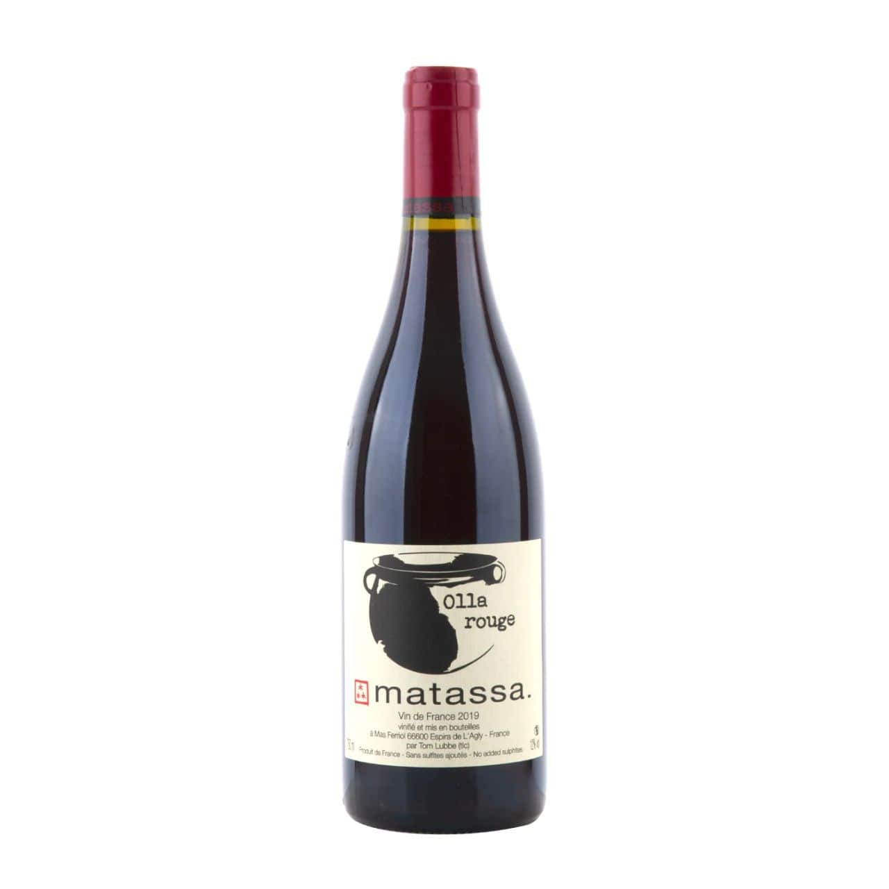

Each bottle tells a story of craftsmanship and terroir, offering a diverse tasting experience for wine lovers. Natural wine gift boxes come in various sizes and styles, catering to different preferences and occasions. Some may feature a mix of reds, whites, and rosés, while others focus on specific regions or grape varieties. With options to suit every taste and budget, these gift boxes make the perfect present for birthdays, holidays, or special celebrations. One of the advantages of choosing a natural wine gift box is the convenience it offers. Instead of scouring shelves or websites for individual bottles, these curated sets streamline the selection process, saving time and effort. Whether shopping for a friend, family member, or colleague, you can rest assured that your gift will be well received and appreciated. In addition to the wines themselves, many natural wine gift boxes include accompanying accessories to enhance the tasting experience.

From elegant glassware to gourmet snacks and tasting notes, these extra touches add depth and sophistication to the gift. Recipients can indulge in a complete sensory journey, savoring each sip and savoring the moment. For those seeking a more interactive gift, natural wine making kits offer a hands on approach to wine appreciation. Whether as a solo project or a group activity, the process of crafting homemade wine fosters creativity and camaraderie. From crushing grapes to monitoring fermentation, every step is an opportunity to learn and experiment. Whether you opt for a natural wine gift box or a wine making kit, the joy of giving and receiving gifts for natural wine lovers is undeniable. These thoughtful gestures not only celebrate a shared passion for wine but also encourage exploration and discovery. So why not treat yourself or someone special to the pleasures of natural wine this season? After all, the best gifts are the ones that leave a lasting impression.

